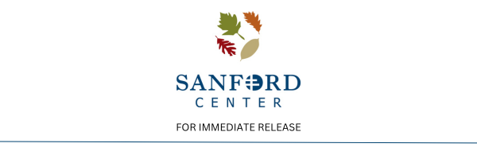

**BABE’S BURNOUT CAR SHOW IS RETURNING TO THE SANFORD CENTER PARKING LOT JULY 12, 2025.**

(**BEMIDJI, MINN**– Mar. 25th, 2025) —The Sanford Center is excited to announce Babe’s Burnout Car Show is BACK this coming July with many fun-filled events!

The 3rd Annual Babe’s Burnout Car Show is returning to The Sanford Center parking lot after a very successful, almost doubled-in-attendance, 2nd annual show last July, which hosted more than 6,000 people and nearly 200 cars. This year promises all the comradery of last year and even more to look forward to.

This year, Babe’s Burnout Car Show will feature numerous vendors and food trucks, the return of the kid zone, live music and a beer tent, a K9 cornhole tournament, an award ceremony, a dyno, and a **BURNOUT PIT** for all who want to experience the thrill!

“We are so excited to announce the 3rd Annual Babe’s Burnout Car Show! With over 6,000 attendees last year, we are on track to the moon! This is quickly becoming a contender for the Largest Car Show in Northern Minnesota! We are so excited to bring this FREE event to our community! We love giving back to the community in a tangible way with an amazing event that has no barrier to come! We couldn’t do this without our amazing group of event sponsors that make this the success it is!” General Manager Bobby Anderson states.

Festivities are scheduled for Saturday, July 12th, from 11 am – 10 pm. This is a **FREE** event for the community to gather, listen to music, check out hundreds of cars, shop vendors, and enjoy the beautiful Bemidji summer with friends and family.

All car spaces for participants will be on a first-come, first-serve basis this year with a full parking lot anticipated. Car load-in for the show will run from 9 am to 11 am on Saturday, with a $10 entrance fee, which includes a complimentary swag bag. Vendor spots are limited, if you are interested in becoming a vendor, please reach out to [lmudrick@thesanfordcenter.com](http://lmudrick@thesanfordcenter.com) to apply. A full detailed timeline will be available in the upcoming weeks.

“Thank you to every one of you who contributed! I cannot wait to see all of you this July at Babe’s Burnout Car Show!” stated Anderson.

Follow Babe’s Burnout Car Show on Facebook for more information and updates following the announcement or check out thesanfordcenter.com/events/detail/2025-babes-burnout-car-show.

**# # #**

**CONTACT:**

Lexi Mudrick

Marketing Manager, The Sanford Center

(ASM Global)

[lmudrick@thesanfordcenter.com](http://lmudrick@thesanfordcenter.com)

Phone: 218-441-4048